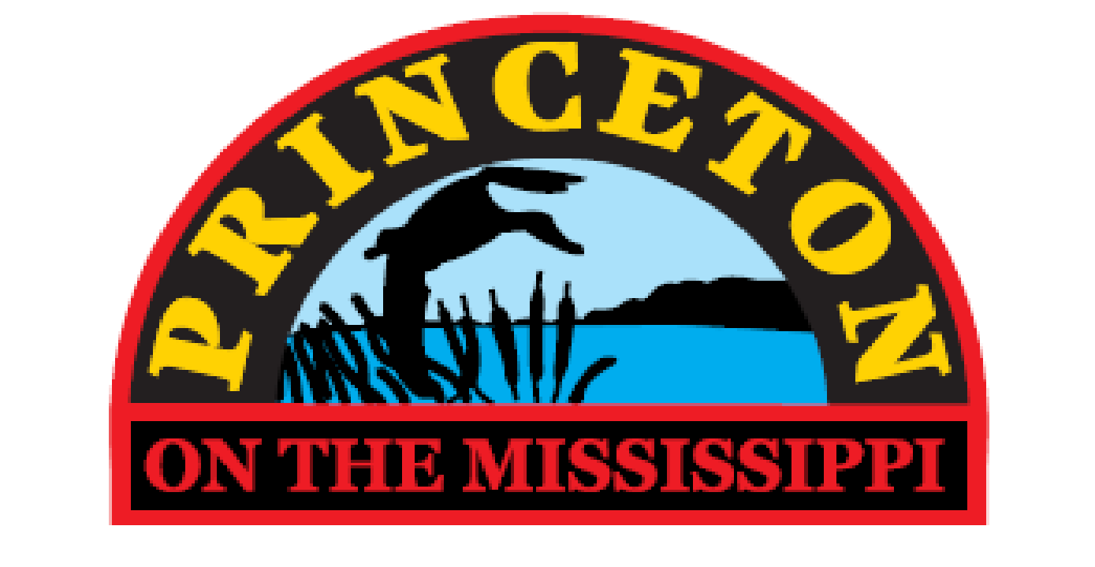

PRINCETON CITY COUNCIL

REGULAR COUNCIL MEETING

THURSDAY, APRIL 11, 2024 AT 6 P.M.
PRINCETON CITY HALL

(PLEDGE OF ALLEGIANCE)

Join FreeConference.com Meeting:

https://hello.freeconference.com/conf/call/9866653

Dial-in using your phone:
United States: +1 717-275-8940

Access code: 986 6653

AGENDA

A. ROLL CALL

B. PUBLIC COMMENT UPON MATTERS ALREADY ON THE AGENDA

C. APPROVAL OF CONSENT AGENDA
“Consent Agenda” means that all items listed below will be automatically approved with one Roll Call vote approving the Consent Agenda. Any City Council member may ask to put an item from the “Consent Agenda” for discussion and a separate vote. The purpose of a “Consent Agenda” is to expedite routine items and allow Council time to discuss more important matters.

1. APPROVAL OF MINUTES:
2. APPROVAL OF BILLS
3. APPROVAL OF NICOLE MATZEN COMMUNITY CENTER RESIGNATION
4. APPOINT JAMI STUTTING TO PRINCETON COMMUNITY CENTER BOARD

D. COMMENTS OR UPDATES OF CITY CLERK OR CITY ATTORNEY:
1.

E. MAYORS COMMENTS:

F. PENDING BUSINESS:
- JIM HUISKAMP PRESIDENT OF BLACKHAWK BANK TO DISCUSS MUNICIPAL BONDS
- COUNCIL TO DISCUSS HIRING A NEW PUBLIC WORKS EMPLOYEE

G. NEW BUSINESS
- COUNCIL VOTE ON HOW TO SELL RETIRED POLICE CAR

H. PLANNING & ZONING ITEMS:

I. RESOLUTIONS:
- RESOLUTION 2024-05; A RESOLUTION AUTHORIZING THE CITY CLERK TO MAKE THE APPROPRIATE INTERFUND TRANSFERS OF SUMS FOR FY 2023/24 FOR THE CITY OF PRINCETON, IOWA

J. ORDINANCES:

K. REPORT OF APPOINTED COMMITTEES
Community Protection
Policy & Admin
Water & Sewer
Streets
Buildings & Inspector (Community Center)
Parks
Trail Committee

COMMENTS FROM THE AUDIENCE
CLOSING DIRECTION FROM CITY ATTORNEY
CLOSING COMMENTS FROM COUNCIL/MAYOR

ADJOURNMENT

NOTICE: Items to be presented to the Council must be in the hands of the City Clerk no later than 4:00 pm on the Thursday before the week of the Council meeting. A packet containing the agenda and documentation for each item listed on the agenda is then prepared on Friday and delivered to each Council member. The next

